CS205 Business Data Management (Level 4)

Fall 2020 – Midterm Project Report

Presentation
This is a simple application aimed to assist the workers of a small branch of a big video game retailer. Both the data and the queries produced are meant to satisfy the needs of the retail workers, when it comes to providing the client with information about their order, and of the manager of the branch when it comes to basic book-keeping concerning the orders and the products. This is not an application aimed to assist with the selling procedure, as it only takes into consideration orders already placed.

The purpose of the application becomes clearer as there exist several columns that are not directly included in the queries provided, but would be rather useful displayed autonomously due to their informative nature. For example, the Metacritic score as well as the playtime, can be information requested by the client, while the max profit margin as well as the monthly sales are extremely important for management.

Table Description
- Ord_id: A simple counting mechanism meant to clearly demonstrate the number of orders placed in a specific time frame.
- Ord_date: The date an order was placed. Useful for gathering data about a specific time period.
- Prod_id: Important for tracking and storage. Could also be used to gather statistical data about the performance of a specific product.
- Prod_name: The title of the product. Can be used for informative purposes.
- Genre: The Genre of the game. Can be used for informative purposes as well as for statistical evidence as to what genre is more popular. Could guide future pricing and distributor deals. (Useless in our case since the pseudo-random generator distributes all data equally, thus eliminating any possible statistical value.)
- Publisher/Dev_studio: Can be important to strike deals with distributors depending on how well the games of a specific publisher/studio are selling. Could also be used for marketing purposes and to inform the clients.
- PEGI-rating/Metacritic-score/Playtime: Trivial information about the game. Can be used for marketing, to inform the client or deduce pricing and discounts for a game.
- Edition: Creates different pricing margins for the same games and is also used for dictating discounts.
- Retail_price/Wholesale_price/Max_Profit_margin: Extremely important data for book-keeping.
- Possible_discount/Monthly_sales; Based on how well a game is selling the maximum possible discount is decided. If a game does extremely well the possible discount drops and if it does poorly the discounts rise to boost sales.
- Shipping: Shipping id comprised of 3 parts:
    - Location of delivery:
      - LOC → Local
      - GLO → Global
    - Urgency:
      - LO → Not urgent
      - ME → Somewhat urgent
      - HI → Very Urgent
    - Prime membership:
      - Y → The client is a prime member and the urgency cost is wavered.
      - N → The client is not a prime member and will be charged accordingly for any urgency of the delivery.

Queries

Simple display of all the data in the original table


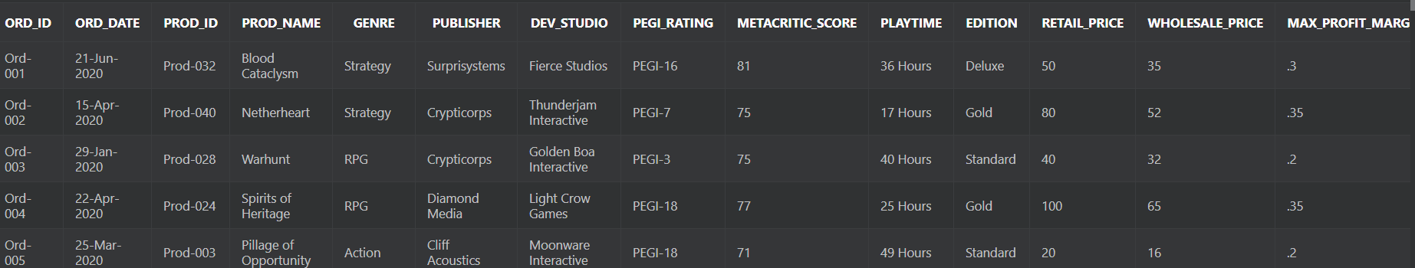
- Simple display of title and ord_id. This exact command could be used for any field and would remain very useful but those cases were omited for the sake of concision.
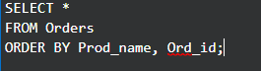

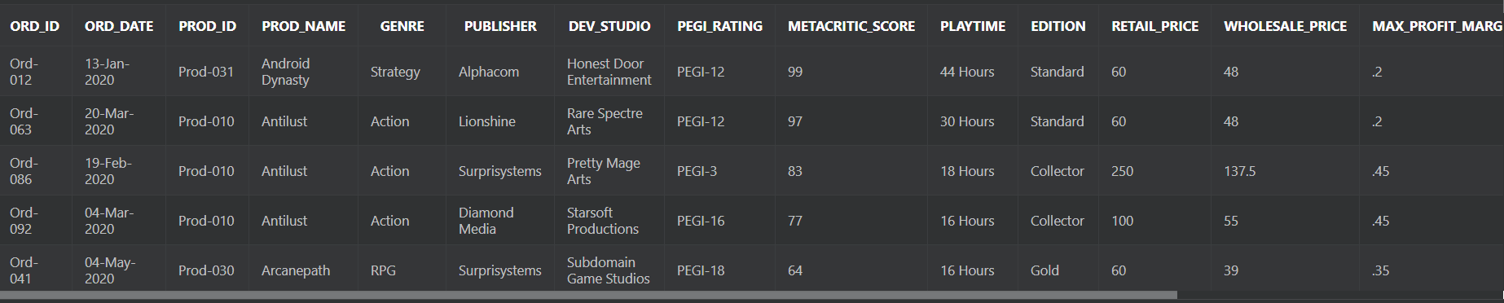

- Display the number of orders placed per month.

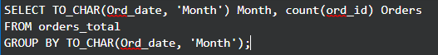

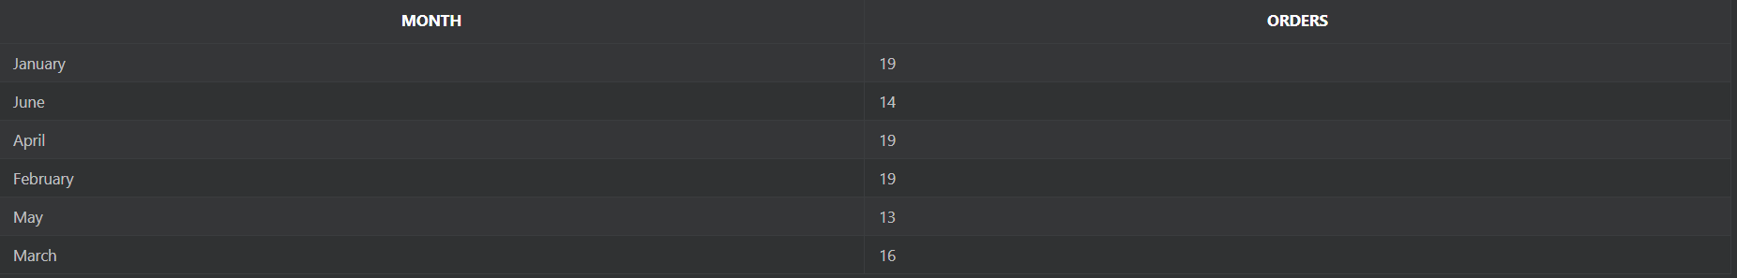

- Returns developer studio popularity based on how many orders were placed on their products. Case function necessary to work with margins.
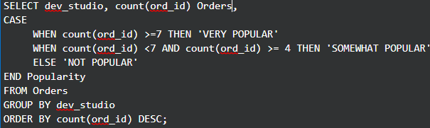
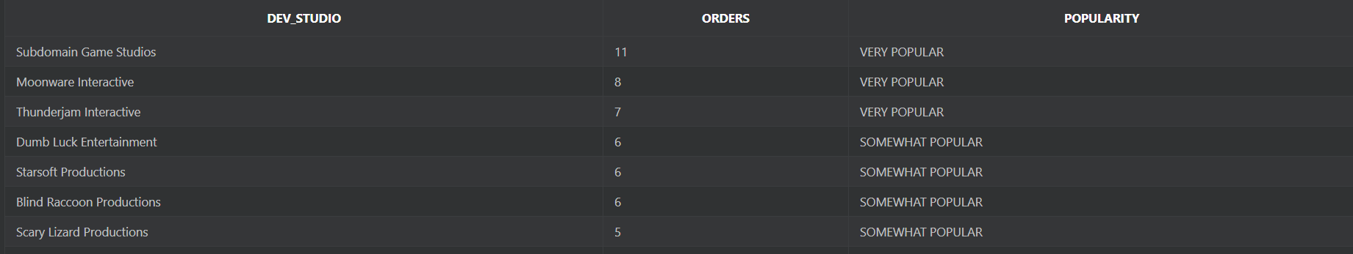

- Creates a view that performs the following tasks:
  - Returns Yes if the game is rated R based on the pegi system or No otherwise.
  - Calculates the final discount by taking into consideration the max possible discount and the edition ordered by the client. The more expensive the edition, the higher the discount.
  - Created a global shipping fee in case the product is not shipped locally.
  - Adds an urgency fee based on the urgency of the order.
  - Returns Yes if the client is a prime member or No otherwise.
  - It also includes all original data.

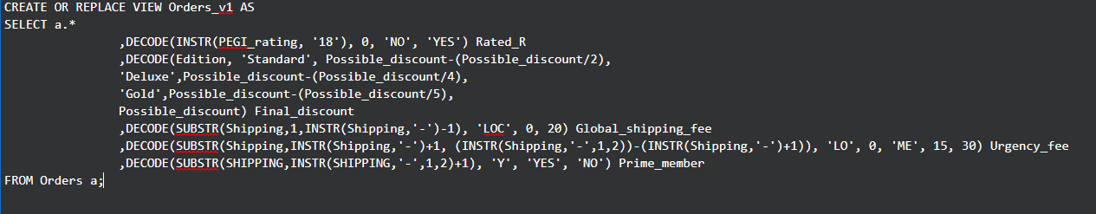
- Calculates the total shipping cost by taking into consideration the case that the client is a prime member and thus has his urgency fees wavered. Kept this operation in a view for ease of repeated use.

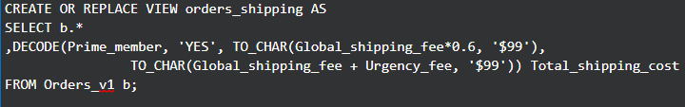

- Calculates the total cost of the order. Kept this operation in a view for ease of repeated use. Both shipping cost and total cost were formatted as currency since they are the data most likely to be displayed without any modifications. The rest of the data were kept in their default formats to avoid unnecessarily excessive complexity of the queries.

- Display handy informational sentences containing a plethora of previously calculated data in a format that is easy to read.

- Summarizes bookkeeping information for the 6 month period covered by the data, in a format that is easy to read.

Suggestions for further development.
This application is in no way complete at it was built to be greatly expandable. Since this application only covers the orders placed on a branch of a big game retailer, one could continue to create more tables for other aspects of the branch or even the parent company, leading to night limitless expansion potential. Furthermore, some aspects like the shipping were not fully utilized in this application. One could take shipping expenses, potential deals based on shipping location, or even money gained from the prime subscriptions to create a more complete profit calculation. In case of the creation of more tables it would be best to remove fields like Metacritic score and playtime and add them in a product table, to be used both in marketing and selling endeavors.

